Configure The Mobile App For Controlling Motor Using Buttons

|  |  |
| --- | --- |
| Date | 10 November 2022 |
| Team Id | PNT2022TMID31893 |
| Title | Hazardous Area Monitoring for Industrial Plant using IoT |

App Blocks to render the values and display it in app

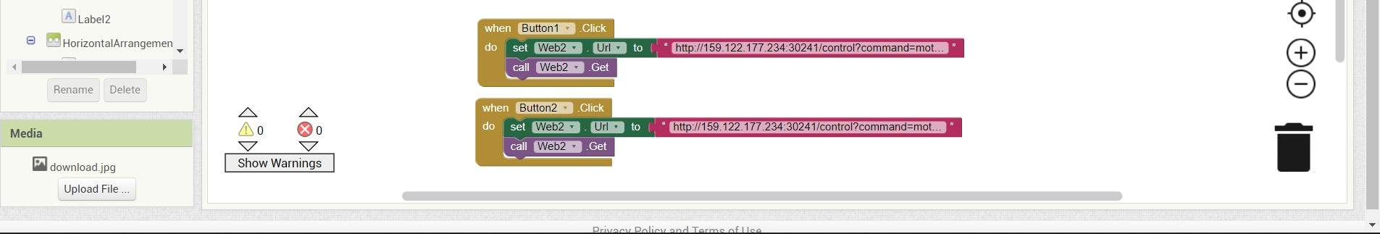

Python block that changes the state of motor based on input from app

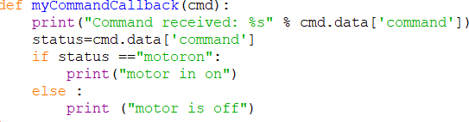

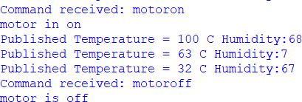Output window